|  |
| --- |
| Business Process Overview |
| **Definition**  This document is for ServiceDesk technicians. It covers all functions used in their day-to-day as well as basic configurations, procedures and processes.  **Use**  To train a new ServiceDesk technician or to consolidate your knowledge about this tool, to make sure every technician worldwide works in the same manner, follow the same processes. |

Table of Contents

Login 3

Vocabulary 3

Home 3

Dashboard 4

Requests 4

Go 4

Views 4

The Interface 6

New Incident 8

Priority 9

Status 9

Mode 10

Category 11

Administration 11

Communication 11

Custom System 11

ERP 11

Hardware 11

Infrastructure 12

Invalid 12

Purchase 12

Security 13

Service 13

Software 13

Group 14

Technician 15

Description 15

Tag 15

Process 15

View Request 17

Resolution 17

Work Log 17

History 17

Solutions 18

What is a Solution? 18

When do I create a Solution? 18

Do I still use Doc-IT? 18

How do I create a Solution? 18

How do I use Solutions? 19

Assets 19

Purchase 19

Contracts 20

Reports 21

Folders 21

New Custom Report 21

Reports Actions 22

Flash Report 22

New Scheduled Report 22

Personalize 23

Dealing with the Requester 23

First contact 23

Asking for equipment to be shipped 23

Three Strikes Rule 23

ACE 24

Handling QCPC in ServiceDesk 24

Handling A3 in ServiceDesk 24

Emergency 7-24 25

Skype Status 25

# Login

To log to the system, you must access this URL in your Internet browser: <http://servicedesk.csl.local>

Then, enter your Windows credentials and click on **Login**:

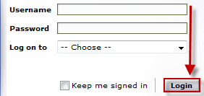

# Vocabulary

* **Ticket** = **Request** = **Incident**: ServiceDesk use these terms as synonyms. In the ITIL concept, a Request and an Incident are different, but not in the ServiceDesk wording.
* **Task**: A task is a "sub request", something someone must do before the request can be closed.
* **QCPC**: This is a term from the ACE protocol meaning Quality Clinic Process Chart. When a request is identified by the QCPC tag, it means that its resolution would help improve the ITIL process behind it (ie: reduce the time of the process or the risk of errors)

# Home

When you open ServiceDesk, you first arrive in the Home tab:

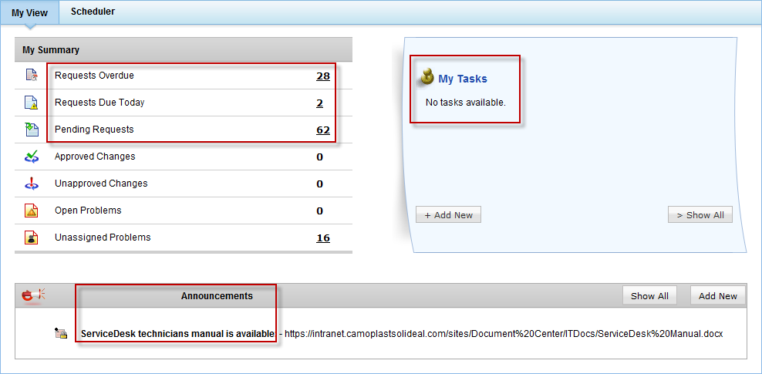

This tab will allow you to:

* See an overview of your requests **Overdue**, **Due Today** or **Pending**
* See the pending **Tasks** that have been assigned to you
* See/Add **Announcements** by IT members
* Access the **Scheduler**, which is a calendar where you can manage your availability and absence as well as see other technician's

# Dashboard

Sadly, ServiceDesk permissions management are currently flawed to the point that the access level required to see the Requests dashboard is too high to be granted to everyone. Only a very limited group has access to it (IT VPs and ServiceDesk admins). So, until this is resolved by ManageEngine, I suggest you to skip this module altogether since it will only give you the dashboard on Assets, which is not very useful for any of you:

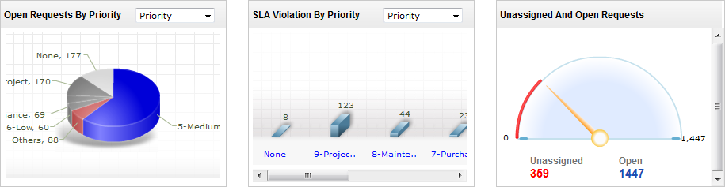

# Requests

This module is the bread and butter of all technicians. Here's an overview of what it can do for you:

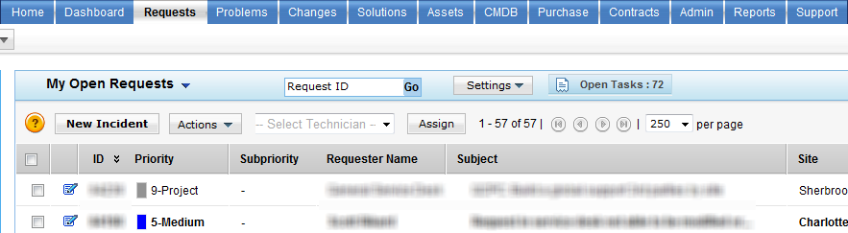

## Go

This is a shortcut where you can just type in a ticket number in order to access it quickly, if you know it.



## Views

This combo box allows you to switch the filter currently applied to all requests. This is a very important feature because it is very rare that you will want to see ALL requests. Usually, you will want to apply a filter (a rule) that will decide which requests are shown, for example: all OPEN requests assigned to ME. There are already several filters by default in the system:

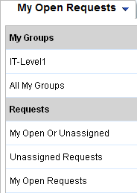

On top of that, all technicians can create custom views. You will see all system and public filters (created by ServiceDesk administrators), but only YOUR private views. To manage views, you must click on **Settings/Manage Custom Views**:

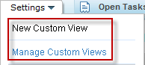

**New Custom View**

After clicking on **New Custom View**, you will be brought to this window:

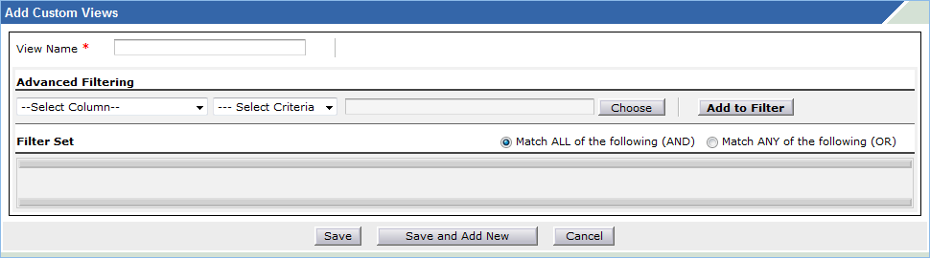

* Choose a **View Name**
* Manage your **Advanced Filtering** rules by **Add**ing **to Filter** a combination of **Column**s + **Criteria**. Each rule must be added separately and you must choose if the logic applied between different rules is **AND** (match ALL rules) or **OR** (match ANY rule). Here's an example:

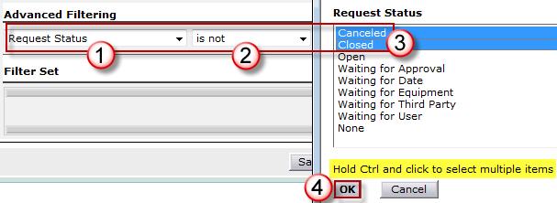

**Show**

You can choose how many requests are showed per page:

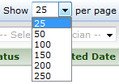

**Refresh**

In the upper right corner of the Requests tab, you can choose to have the requests list refreshed automatically at a certain interval:

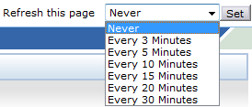

## The Interface

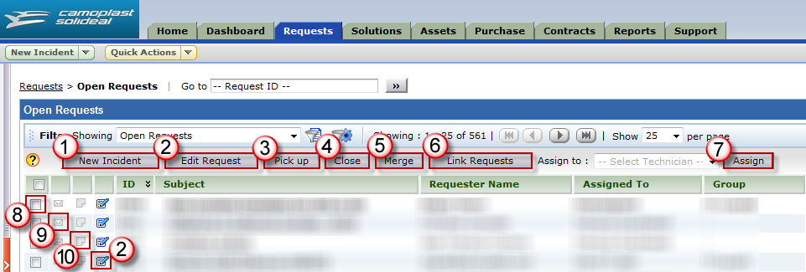

* 1) **New Incident**: Creates a new ticket
* 2) **Edit Request**: Edits selected request(s). Yes, it is possible to select multiple requests and modify them at the same time by selecting multiple tickets and clicking on **Edit Request**.

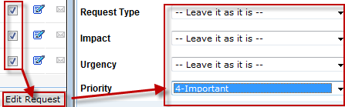

* 3) **Pick up**: Assigns selected request(s) to you
* 4) **Close**: Changes the status of selected request(s) to **Closed** (completed)
* 5) **Merge**: Merges selected tickets together. You must select at least 2 tickets to perform this. All requests will merge into the oldest (smallest) ticket **ID** and all details will appear in this ticket's **Requester Conversations**. All the **Work Log**s will be summed together. You must use this when you discover that 2 similar requests were created for the exact same issue and want to track them together instead of separately. Note that a merge CAN be undone.
* 6) **Link Requests**: Links selected tickets together. You must select at least 2 tickets to perform this. A clickable link will be added to each request to be able to easily navigate between all of them, using their ID#. Use this when several requests are part of the same parent project and you want to group them together. A ticket with linked requests will have the Linked Requests button in the top right corner:



You can click on it to see the clickable linked tickets, or to **Remove Link**:

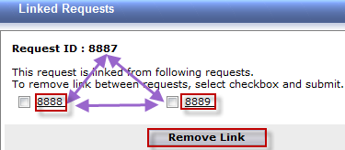

* 7) **Assign**: Assigns the selected request(s) to a specific technician
* 8) **Select box**: Check these to select ticket(s)
* 9) **Reply icon**: This icon shows the reply history current status:
  + : No reply history
  + : Last conversation entry was from the technician or the system
  + : Last conversation entry was from the requester (the ball is in our camp)



* 10) **Notes icon**: This icon shows if there is a note or note attached to the request.
  + : No note. You can click on it to add one.



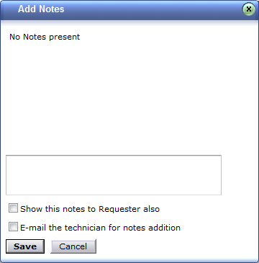

* + : Note. You can click on it to read it or add more:



## New Incident

If you click on the **New Incident** button or if you open an existing request with one of the **Edit** buttons, you will open the request in Edit mode and thus be brought to the screen where all the fields are editable:

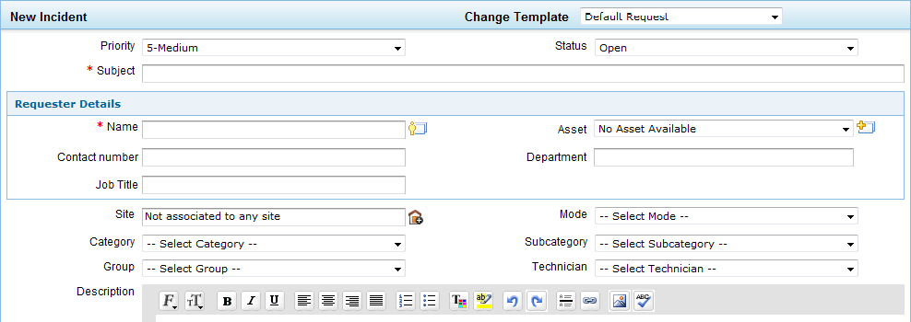

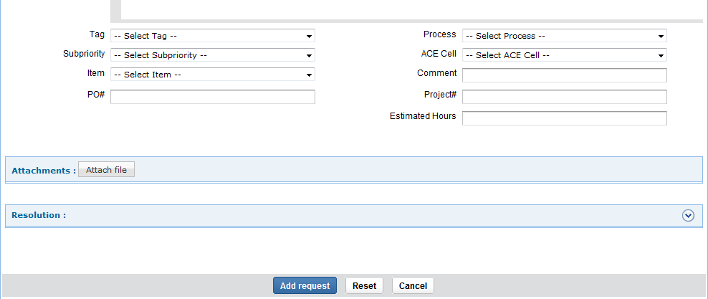

To save a new request, click on the **Add request** button. To save modifications to an existing request, click on the **Update request** button. Both are at the very bottom of the screen.

## Priority

The priority of the request is mostly logical but also subjective. The dispatcher and/or the technician are responsible to set/change the priority based on the facts (impact) and the needs (urgency). Then, the **Due Date** will be calculated based on the associated Service Level Agreement (SLA). Here's the table with all the priorities and their definition, as well as their SLA response and closure time and if the SLA overlaps working hours or not (Overtime):

|  |  |  |  |  |
| --- | --- | --- | --- | --- |
| Priority | Definition | SLA Resp | SLA Close | Overtime |
| 1-Critical | Production or shipping is down. | 30 mins | 4 hrs | True |
| 2-High | One user is unable to work or significantly hindered. | 1 hr | 8 hrs | False |
| 3-Medium | Standard request or task. Does not hinder day to day work. | 1 day | 2 days | False |
| 4-Low | No or low impact or visibility to the end-user. | None | 14 days | False |
| 5-None | No priority associated to this request | None | 1 year | False |

## Status

The status is the current state of the request. Ultimately, there are only 2 different states: the request is either **Open** or **Closed**. However, the different statuses help us by adding a degree of precision to what is happening, thus giving us more reporting flexibility and also by stopping the timer when appropriate. The timer is the clock behind ServiceDesk which monitors if the requests bust or not the established SLA.

|  |  |  |
| --- | --- | --- |
| Status | State | Timer |
| **Canceled** | **Closed** | **Stopped** |
| **Closed** | **Closed** | **Stopped** |
| **Open** | **Open** | **Running** |
| **Waiting for Approval** | **Open** | **Stopped** |
| **Waiting for Date** | **Open** | **Stopped** |
| **Waiting for Equipment** | **Open** | **Running** |
| **Waiting for Internal Expert** | **Open** | **Running** |
| **Waiting for Third Party** | **Open** | **Running** |
| **Waiting for User** | **Open** | **Stopped** |

**Subject**

This is simply the title of the request. This should be as precise as possible and not too long. Try avoiding very generic subjects such as "bug" or "IT problem". Don't hesitate to modify the subject after the request has been assigned to you, if there is added value doing so.

**Name**

Full name of the requester. You can start typing it and then select it from choices given by ServiceDesk. This field is used to populate the 4 other fields in the **Requester Details** section, as well as the Site. When there is no specific person behind the request, you can put it under "General *<City>*". When someone is putting in a ticket on behalf of someone else, you need to change the Requester to that person who is having the problem or need.

**Asset**

Name of the main computer associated to the requester.

**Contact number**

Telephone where to reach the requester.

**Department**

Department name or number associated to the requester. This field is very important because it is used by ServiceDesk to determine the location where the request comes from.

**Job Title**

Job title of requester.

**Site**

**City** of requester. This is a very important field, so make sure it is correct before closing a request.

## Mode

The method by which the request has reached the support team.

|  |  |
| --- | --- |
| Mode | Description |
| Bypass | The request has been submitted directly to a technician, bypassing the support normal process, either by email, phone, chat, live or any other method. |
| E-Mail | The request has been submitted by email to [support@camoplastsolideal.com](mailto:support@camoplastsolideal.com). |
| Page | The request has been submitted through the emergency channel, paging one of the technicians for immediate assistance during or outside normal business hours. |
| Phone | The request has been submitted by telephone to one of the main published IT support telephone numbers (e.g., x2222). |
| Web Form | The request has been submitted by the Requester using the self-service [ServiceDesk](http://servicedesk.csl.local) portal or has been created directly by a system (e.g., ServiceDesk or OpManager). |

## Category

The **Category** is the 1st layer of categorization of a request, 2nd layer being the **Subcategory**, 3rd layer being the **Item**. Category+Subcategory are mandatory before closing a request. Item is only used for a couple of ERP subcategories. It is important to classify requests correctly because statistics depend on this.

### Administration

All general internal administrative tasks (for the IT department).

|  |  |
| --- | --- |
| Subcategory | Description |
| Absence | To track when you are not working. |
| Dispatch | Dispatching time, ie: very basic troubleshoot prior to escalation, classification, etc. |
| Internal | Time spent helping coworkers or doing improvement tasks beneficial to our own department instead of our internal/external customers. |
| Meeting | Time spent in meetings. |
| Planning | Time spent planning work or projects. |
| Training | Time spent being trained for the business.  Do not confuse with training a user, which should be Software/... |
| Travel | Time spent traveling for the business. |

### Communication

Requests related to communication tools and devices repair, bugs or configuration.

|  |  |
| --- | --- |
| Subcategory | Description |
| Fax | Fax transmission, confirmation, etc. |
| Mobility | Mobile units requests, ie: bug, question or plan for cell, Blackberry, iPhone, etc. |
| Modem | Modem communication issues that are not hardware or related to our RAS. |
| Telephone | Request about a telephone, land line, cabling, BCM, etc. |
| Videoconferencing | Videoconferencing requests, ie: Polycom. |
| VOIP | VOIP issues not related to the software themselves. |

### Custom System

All custom software developed by Camoplast Solideal or for Camoplast Solideal.

### ERP

ERP requests.

|  |  |
| --- | --- |
| Subcategory | Description |
| Compiere | Compiere tickets (EU-APP) |
| Epicor | Epicor tickets (US-APP) |
| SAP | SAP and its modules, ie: eCommerce. ( IT-BPA, SL-BPA) |

### Hardware

Requests related to hardware repair, bugs, drivers or configuration.

|  |  |
| --- | --- |
| Subcategory | Description |
| Gun | Barcode readers/scan guns issues, ie: configuration, trigger, keyboard, etc. |
| Laptop | Laptop computers issues, ie: configuration, motherboard, touchpad, RAM, etc. |
| Monitor | Monitor, projector or TV issues, ie: LCD, port, cable, etc. |
| Networking | Hardware problem with networking equipment, ie: router, access point, etc. |
| Other | Any other hardware issues. |
| PC | Desktop computers issues, ie: configuration, motherboard, power supply, RAM, etc. |
| Printer | Printer, scanner, copier or fax issues, ie: configuration, fuser, toner, paper jam, etc. |
| Thin | Thin client terminal issues, ie: configuration, motherboard, port, RAM, etc. |

### Infrastructure

Requests related to the infrastructure.

|  |  |
| --- | --- |
| Subcategory | Description |
| Firewall | Firewall related issues. |
| LAN | LAN issues, ie: Intranet, switch, patch panel, RAS, IP, cabling, access point, etc. |
| Mail | Mail Server/Exchange service issues. |
| Maintenance | Time spent on infrastructure maintenance, ie: scheduled reboot, upgrade, etc. |
| Router | Non-hardware, non-LAN, non-WAN issue with routing capabilities of a router. |
| Server | Issues related to servers, outside of regular maintenance, TS and mail servers. |
| Storage | Issues related to SAN or servers disk space. |
| TS | Terminal Server/Citrix service issues. |
| UPS | Issues related to UPS backup batteries. |
| WAN | WAN issues, ie: Internet, router, VPN, WAN accelerator, registrar, etc. |
| Web Access | Issues related to Web Access/Portal (webaccess). |

### Invalid

Requests that are not really requests or are duplicates of other requests.

|  |  |
| --- | --- |
| Subcategory | Description |
| Duplicate | This request is invalid because it's the same as another request or a follow-up. |
| Null | Mistakenly sent to the help desk, ie: Thanks, Out of Office, wrong address, etc. |
| SPAM | This is not a request, but unsolicited mail from a 3rd party. |

### Purchase

Purchasing requests.

|  |  |
| --- | --- |
| Subcategory | Description |
| Communication | Purchasing communication equipment, ie: iPhone, telephone, headset, etc. |
| Hardware | Purchasing any hardware outside the Communication subcategory. |
| Maintenance | Purchasing maintenance contracts on hardware or software we own. |
| Office Supplies | Purchase of office supplies like toner, mouse pads, pens, etc. |
| Resource | Purchasing time for the service of an external resource such as a consultant. |
| Software | Purchasing any software license or media. |

### Security

Requests related to the security of the company's infrastructure, employees, data and property.

Do not confuse with **User Management** when it comes to employee's permissions in the data systems.

|  |  |
| --- | --- |
| Subcategory | Description |
| Alarm System | Requests about the alarm system, ie: permissions, password, problem, etc. |
| Backup | Backup or restore requests or problems, ie: DataProtector, Druva, etc. |
| Camera | Requests around surveillance cameras, ie: video after theft or accident, bug, etc. |
| Data | Security around company data, like hard drive and cell phone disposal, etc. |
| Door | Security around doors and gates, ie: servers room, entry door, Chubb, etc. |
| Encryption | Security encryption requests, ie: encrypting/decrypting a laptop drive, bug, etc. |
| Hacking | Time spent resolving hacking attempts related issues, ie: phishing, attack, etc. |
| Internet Filtering | Requests about blacklisting/whitelisting web sites, ie: Websense. |
| Malware | Virus, worm, trojan, spyware or adware related issues, ie: virus cleaning, anti-virus definition update, client upgrade, spyware removal, etc. |
| Password | Time spend around password policies enforcement and rules. |
| SPAM | Requests about blacklisting/whitelisting email addresses, ie: Barracuda. |

### Service

General service rendered to users.

|  |  |
| --- | --- |
| Subcategory | Description |
| Building | Building management, ie: external dispatching for electricity, plumbing, etc. |
| Communication | Information communicated to employees to have them aware of issues, projects, etc. or to prepare or train them for something. |
| Data | Files restore, moving data from one place to another or changing data structure. |
| Installation | Physical installation of hardware equipment for the user, ie: computer, printer, etc. |
| Personal | Personal service or advice given to user, ie: home computer, home WIFI, etc. |
| Scan | Scanning documents for users. |

### Software

Requests related to software bugs, installation, training, configuration or tasks.

## Group

Instead of assigning a request to a technician, you can assign it to a **Group** of technicians. Members of that group will see these requests in the same views where they see their own requests. On top of that, some members of a group will receive an email, if they are configured for this. Not all members of a group necessarily receive these emails. This is an independent configuration done by the ServiceDesk administrators. If you want to start or stop receiving emails in your group, you can ask them.

Here are the different groups definition and purpose:

|  |  |  |
| --- | --- | --- |
| Support Group | Based in | Support functions |
| **EU-App** | Europe | Europe’s ERP (Compiere). |
| **EU-Level2** | Europe | technical requests. Basicaly, all Europe requests that are not handled by EU-App. |
| **IT-App** | Sherbrooke | Camoplast Solideal’s developed/custom applications. Support Lotus Notes and MS Access databases and apps. |
| **IT-Basis** | Sherbrooke | Last level of escalation for SAP support. |
| **IT-BI** | Sherbrooke | SAP tickets related to BI (Business Intelligence). |
| **IT-BPA** | Sherbrooke | First level of troubleshoot for SAP support. |
| **IT-BPA_FI-CO** | Sherbrooke | SAP tickets related to FI-CO modules. |
| **IT-BPA_MM** | Sherbrooke | SAP tickets related to MM modules. |
| **IT-BPA_PP** | Sherbrooke | SAP tickets related to PP modules. |
| **IT-BPA_PS** | Sherbrooke | SAP tickets related to Polymer Solutions (Roxton Falls plant). |
| **IT-BPA_SD-EDI** | Sherbrooke | SAP tickets related to SD-EDI. |
| **IT-CER** | Sherbrooke | CER tickets coming from on-site CER power users. |
| **IT-Collab** | Sherbrooke | Collaboration Tools tickets (SharePoint). |
| **IT-Infra** | Sherbrooke | Tickets related to the IT Infrastructure worldwide. |
| **IT-Level1** | Sherbrooke | 1st line of entry for all tickets not automatically dispatched by the system. First troubleshoot before escalation to other groups. Reassign to this group with a work log explaining why you do when you want a request to be rerouted to another support group. |
| **IT-Level3** | Sherbrooke | 3rd level of escalation for technical IT tickets, after IT-Level1 and IT-Level2. |
| **KR-App** | South Korea | Camoplast Solideal’s developed/custom applications. |
| **RK-BPA** | Plattsburgh | 1st level of troubleshoot for SAP support specific to Rockland division (Plattsburgh/Peosta/Emporia). |
| **SL *<location>*** | Sri Lanka | 1st level of troubleshoot for all technical tickets based on-site *<location>* (ie: SL Pelana Warehouse). |
| **SL-App** | Sri Lanka | Camoplast Solideal’s developed/custom applications. |
| **SL-Basis** | Sri Lanka | Last level of escalation for SAP support in Sri Lanka. |
| **SL-BPA** | Sri Lanka | 1st level of troubleshoot for SAP support in Asia. |
| **SL-BPA2** | Sri Lanka | 2nd level of escalation for SAP support in Asia. |
| **SL-Infra** | Sri Lanka | Tickets related to the IT Infrastructure in Asia. |
| **SL-Level2** | Sri Lanka | Technical tickets from China and South Korea. |
| **SL-PDB** | Sri Lanka | PDB tickets (Product Database, World Tire in Asia). |
| **US-App** | USA | SUSA’s ERP (Epicor). |

## Technician

This is where you see who the request is assigned to or where you can assign it to someone. When you change that, the new technician will receive an email with the details about the request. Most technicians in there have the login capability to the ServiceDesk tool, but not everyone. Keep in mind that all technicians with login capability cost one license.

## Description

This is where all the details about the request are found. Try to be as much specific as you can. You can also insert pictures from files, but cannot copy/paste them directly here. However, when ServiceDesk receive a print screen contained in an email, it is able to interpret it and plug it here, which is a very useful feature. Usually, initial description of a request should not be modified any more once work on the request has started.

## Tag

Use this field to add an additional tag to a request. This is a custom field adapted to our reality with tags not needed by everybody. The most standard examples are the Meeting tags or ACE tags (QCPC/A3).

## Process

This is the ITIL process associated to this request. Use it only if necessary, and only if you understand ITIL methodology. It's better to leave this field blank than to add something wrong when you're not sure.

**Subpriority**

When you need a deeper level of prioritization because you have too many requests with the same Priority, this is what you will use. Just enter a number from 1 (highest) to 9 (lowest) in each of your requests and you'll then have the possibility to sort them accordingly. You can also select the Subpriority “Tree-3”, if useful for your projects planning.

**Estimated Hours**

Useful for projects load balancing and planning, this is where you will enter the amount of hours estimated to bring this request to completion.

**Comment**

This is a free custom field.

**PO#**

Purchase Order number, when request is a purchase, to help finding it in the purchasing system.

**Project#**

Project number (ie: Capex or Asset) useful to group together different requests about the same project.

**Attachments**

You can click the **Attach file** button to add files to the request.

**BU/Function/Ops**

You can select BU / Function / Global operation of the demand.

|  |  |
| --- | --- |
| Subcategory | Description |
| BU-Ag | BU Agriculture |
| BU-Con | BU Construction |
| BU-Em | BU Emerging Markets |
| BU-PS | BU Powersports |
| GF-Fin | Global Function – Finance |
| GF-HR | Global Function – Human Ressources |
| GF-IT | Global Function – Information Technology |
| GF-LA | Global Function – Legal Affairs |
| GF-Mkt | Global Function – Marketing |
| GO-AT | Global Operations – Advanced Technology |
| GO-Fin | Global Operations – Finance |
| GO-HS | Global Operations – Health & Safety |
| GO-LT | Global Operations – Leadership Team |
| GO-Log | Global Operations – Logistics |
| GO-MD | Global Operations – Mixing Division |
| GO-NPT | Global Operations – Non Pneumatic Tire |
| GO-Pro | Global Operations – Procurement |
| GO-SC | Global Operations – Supply Chain |
| GO-SL | Global Operations – Sri-Lanka |
| GO-Tra | Global Operations – Transports |
| GO-WH | Global Operations – Logistics & Warhouses |

## View Request

In the **Requests** main tab, if you click on a request title, you will open this request in View mode, instead of Edit mode. Once inside a request, you'll be in the **Request** sub tab, where you will find all the details:

* Subject
* Description
* Requester Conversations
* Request Details
* Requester Details

## Resolution

You must use this tab only to enter the final **Resolution** of the ticket. Keep in mind that, once you will close the request, the requester will receive an email with your Resolution. Thus, the resolution is mandatory and must be clear, straightforward, simple, professional and easy to understand. Once your solution is written, you can Change status to Closed, and also Add Work Log to track the time you spent on the request (see below).

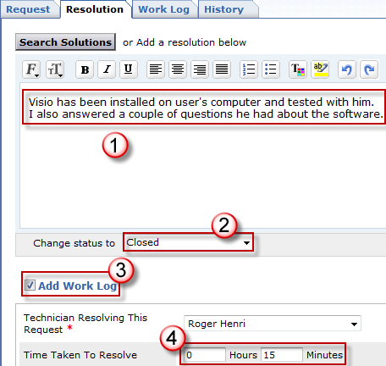

When done, click on the **Save** button at the very bottom.

## Work Log

This is where you will enter all the steps you took during the resolution that took a certain amount of time to execute. If, for example, you installed Visio and it took 15 minutes, you can enter 1 entry in there of 15 minutes saying "Visio installation". If you call a user and leave a voicemail, you can put there an entry of 5 minutes saying "Left VM" and change the Status of the request to "Waiting for User". Note that several DIFFERENT technicians can write entries toward the resolution of the same ticket, so you must avoid creating several tickets for the same problem.

## History

Tracks the history of the request, meaning who modified what and when.

Customization

# Solutions

## What is a Solution?

cid:image002.jpg@01D218DE.675C1520An answer to a question or a fix to an incident end-users could have

## When do I create a Solution?

Whenever you encounter a situation where you have the answer to a question or a fix to an incident end-users could have and that this Solution does not already exist in the Solution database. Anything that you could need as a live "Online" agent.

## Do I still use Doc-IT?

Yes: Doc-It will still be there if you want to store documents that are not Solutions, such as complete Work Instructions, reports, etc. Anything that you would NOT need as a live "Online" agent.

## How do I create a Solution?

1. In ServiceDesk, go in the Solutions tab and click on **New Solution**.
2. **Title**: Enter a simple, straight-to-the-point, self-explanatory and clear title, representing directly what is the question you are answering or the incident you are fixing
3. **Content**:
   * Detail your answer/fix by being as clear, short and simple as possible
   * Use screenshots only when it is necessary and keeping them small and accurate
   * Try to use a step 1-2-3 methodology when applicable
   * Write in English
   * Keep a ratio of 1A to 1Q, meaning 1 question or incident = 1 answer or fix. If you cover a subject and have 5 different questions/incidents/answers/fixes, you need to create 5 different Solutions.
4. **Topic**: Select the appropriate Topic. If it does not exist, ask me to create it (**Roger Henri**)
5. **Keywords**: Enter all the keywords you think someone could think of during a Solutions search. Separate all words by a comma.
6. Click on **Add** to add your Solution to the database
7. In the **Approve Actions** menu, click on **Submit for Approval**

cid:image005.png@01D218DA.91F0F2F0

1. To the right of the **To** field, click on the Add users **icon** and then check **Martin Burelle** and click on the **Send** button:



Martin will then review your solution and if it's accurate and up to our quality standards, will approve it and it will become an official **Approved Solution**.

**Homework**: Feed this database. Please try to find any Solution that you might have somewhere and convert your wisdom into official Solutions that will be used by the whole team.

Here are examples of places famous to hold Solutions outside of ServiceDesk:

* Doc-IT
* Post-It
* OneNote
* Your brain
* Windows Desktop
* H: drive

## How do I use Solutions?

Type your search in the field and make sure to select Approved Solutions. You don't want to use a Solution that is not approved... don't you?

cid:image007.png@01D218DE.675C1520

# Assets

This is where you can manage assets (computers, servers, etc.). This is currently being implemented.

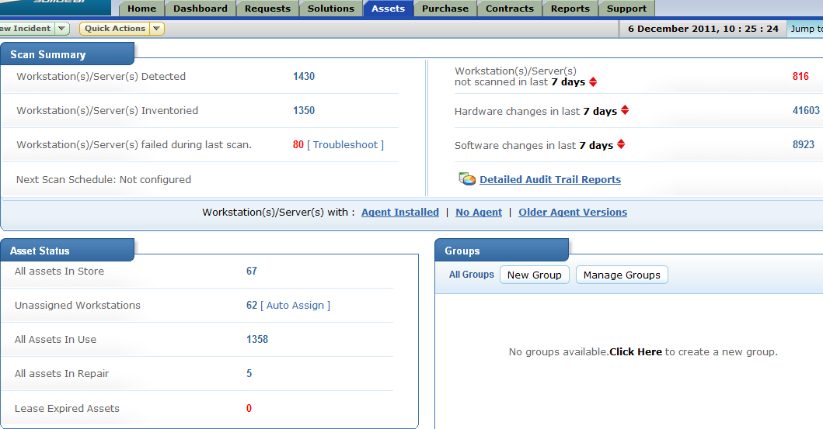

# Purchase

This is where you can manage and track purchasing. Right now, this feature is not used by Camoplast Solideal, so you can skip this module.

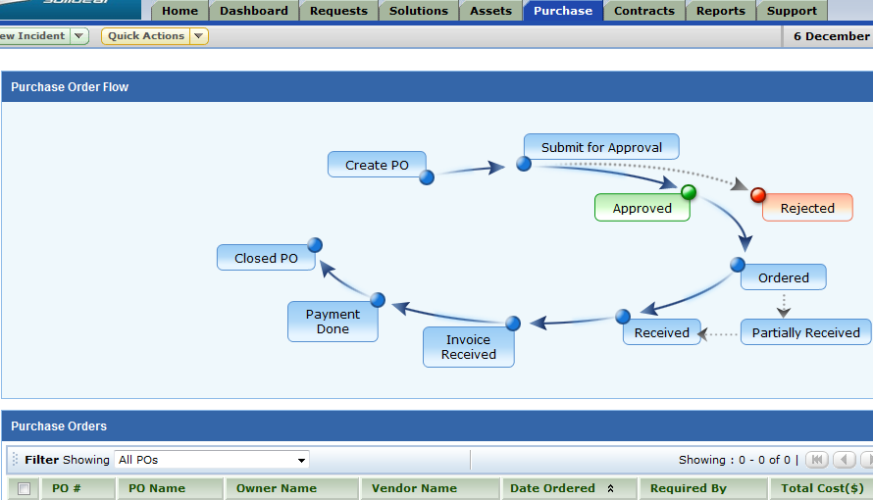

# Contracts

This is where managers keep the different IT contracts.

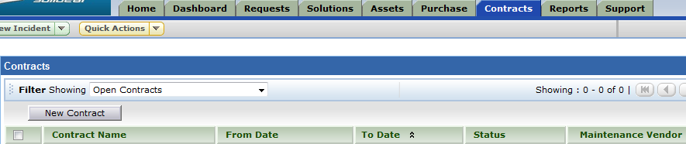

# Reports

This is where we manage the reporting. Your level of permissions in ServiceDesk will determine if you can create private or public reports and if you can modify or delete them.

## Folders

Currently, custom reports are classified under 4 different folders only. All other folders are system folders and contain reports that are native from ServiceDesk. It is strongly advised to only use those in the custom folders since they are more likely to fit your needs by being more adapted to your reality:

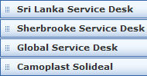

* **Sri Lanka Service Desk** folder applies to Sri Lanka technicians only.
* **Sherbrooke Service Desk** folder applies to Sherbrooke technicians only.
* **Global Service Desk** folder applies to global Service Desk technicians only (Martin Burelle's team)
* **Camoplast Solideal** folder applies to all technicians in ServiceDesk.

## New Custom Report

To create a new report, choose its title, its type (**Tabular** are much simpler) and the module (most likely **All Requests**) and then click on **Proceed to Report Wizard**:

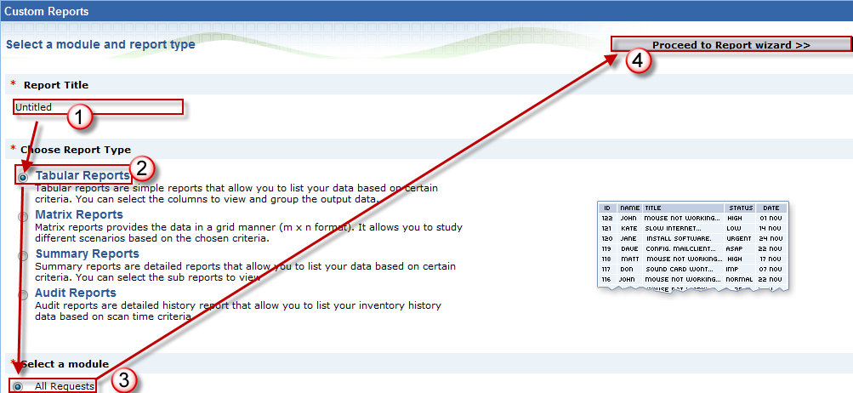

* **Step 1**: Select columns to display
* **Step 2**: Choose the Date Filter and the Advanced Filtering criteria
* **Step 3**: Select Column to group by, and the columns to order by
* **Step 4**: Select summary type, most likely the Count of Request ID
* **Step 5**: Select Chart Type, ie: Pie Chart 2D, with Axis Column and Display Format
* **Step 6**: Click on Run Report
* **Step 7**: Click on Save Report; there you will have to enter the Report Name, if the report is Public or Private, the Save-in Folder and de Description of the report.

## Reports Actions

Once you run a report, new or existing, you can do the following actions on it:





* **Save report as** to create a new copy of it with another name
* **Schedule** to launch the New Scheduled Report window (see below)
* **Show Query** to see the MySQL query behind the report, if applies
* **Mail this Report** to send it by email; you'll have to choose the recipient(s) and the file format
* **Graph View** to view only the graph of a report, if a Chart Type has been selected for it
* **Print Preview** to peek at what the file will look like once exported
* **Export as** to save the file as HTML, PDF, XLS or CSV (no, XLSX is not yet available)

## Flash Report

Use this if you want to create a very quick report with only basic parameters and don't need to keep it.

## New Scheduled Report

This module can be very useful to you. It allows you to program the system to run reports at a specified date and time and send them automatically to you and/or other recipients. All scheduled reports you create are only visible by yourself.

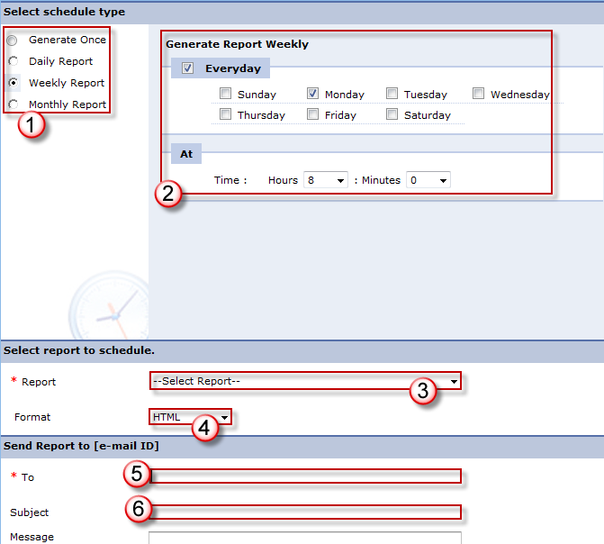

* Select the time interval (ie: Weekly)
* Select the **Time** specifics (ie: Every Monday at 8:00)
* Select the **Report** you want to schedule from all existing reports list
* Select the **Format** of the file the system will send (ie: HTML)
* Select the **Recipient**(s) of the email (separate multiple recipients with a ";")
* Choose a **Subject** for your email
* Click the **Save** button

# Personalize

A very nifty feature that is often overlooked in ServiceDesk is the **Personalize** menu, in the upper right corner of the main interface:



There, you can personalize the following settings for your account:

* Choose **Display Language**
* Select **Time Zone** very important if different from server default (GMT-5:00)
* Set **Date Format**
* Set **Time Format**
* Define **E-mail Signature** for email replies done inside ServiceDesk
* **Change Password** not useful since it is synched with your Windows password

# Dealing with the Requester

## First contact

We strongly advise that you try to contact the requester by telephone, when possible. If you don't reach the requester, you must then leave a voice mail with the coordinate to reach you back, add a work log stating you did so and changing the request status to "Waiting for User".

## Asking for equipment to be shipped

Sometimes, you will need the end-user to ship you equipment. When you do, make sure to ask them to add the **WO#** somewhere in the box (written directly on the box or on a piece of paper inside the box). This way, anyone who will receive the box will know what it is, who it is from and who asked it.

## Three Strikes Rule

1. If the user has not contacted you back after 1 working day, you must contact him or her again by another method (by email if 1st time was a voice mail, or by telephone if 1st time was an email). Always be polite and clear on the reason you call and how to reach you back. If you receive an out of office reply, you must change the status to Waiting for Date and restart the process at the date of return.
2. If after another working day the user has not contacted you back either, you must contact him or her one last time.
3. After a 3rd working day without any feedback from the end-user, you must close the request by entering the following text (English or French) in the **Resolution**, so the requester will receive it by email upon closure:

**English**

Since we have been unable to reach you for 3 working days, we are closing the request for now.

If you need to reopen this ticket, please do not hesitate to contact me directly and it will be a pleasure to help you. Kind regards, *<Contact Info>*

**Français**

Puisque nous avons été incapables de vous rejoindre au cours des 3 derniers jours ouvrables, nous fermons votre requête pour le moment. Si vous avez besoin de rouvrir ce billet, n'hésitez surtout pas à me contacter directement et il me fera plaisir de vous assister. Merci, *<Contact Info>*

# ACE

## Handling QCPC in ServiceDesk

[https://intranet.camoplastsolideal.com/sites/Document%20Center/ITDocs/Handling%20QCPC%20in%20ServiceDesk.docx](https://intranet.camso.co/sites/Document%20Center/ITDocs/Handling%20QCPC%20in%20ServiceDesk.docx)

## Handling A3 in ServiceDesk

1. Start your A3 based on the official **ACE template**: [https://intranet.camoplastsolideal.com/ace/Documents/A3%20Problem%20Solving%20Template%20-%20English%20v2.4.xlsx](https://intranet.camso.co/ace/Documents/A3%20Problem%20Solving%20Template%20-%20English%20v2.4.xlsx)
2. While you are building your document, you must make it shared and accessible by keeping it in a SharePoint location (such as [**Doc-IT**](https://intranet.camso.co/sites/Document%20Center/ITDocs/Forms/AllItems.aspx) and [**PMO**](https://intranet.camso.co/pmo/Assets/Pages/AllActives.aspx)).
3. Once you deem your A3 to be mature enough, you must **upload it to** [**Doc-IT**](https://intranet.camso.co/sites/Document%20Center/ITDocs/Forms/AllItems.aspx):
   1. [**Doc-IT**](https://intranet.camso.co/sites/Document%20Center/ITDocs/Forms/AllItems.aspx) will be the **final container** where all our A3 will be stored: [https://intranet.camoplastsolideal.com/sites/Document%20Center](https://intranet.camso.co/sites/Document%20Center/)
   2. Upon defining document's properties, make sure to select the **A3 IT Document Type**:

cid:image002.png@01CE3F57.968E5CE0

1. In ServiceDesk, create a new ticket using the **New A3 template**:
   1. Under the Request Catalog, click on **New A3**:

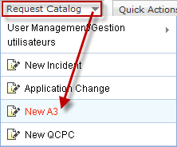

* 1. Fill all the fields, especially the required fields. This looks alike the QCPC template, except that you now have the **mandatory URL field**:

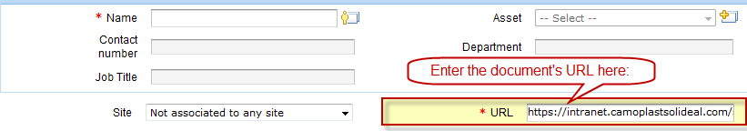

# Emergency 7-24

## Skype Status

Ensure your Skype Status is set as “on call” when it’s your turn to take Emergency calls.

World wide technicians will be in better position to reach you if necessary.

Fill the document [https://intranet.camoplastsolideal.com/sites/Document Center/ITDocs/7-24 Emergency Support Calendar.xlsx](https://intranet.camso.co/sites/Document%20Center/ITDocs/7-24%20Emergency%20Support%20Calendar.xlsx).

*Keywords: ServiceDesk Technician Manual FAQ Readme Instructions Technicians Hand Book Service Desk Interface Instructions 3 strikes rule*